**ARDUINO LAB**

**MANUAL**

**LAB 6: BLACK AND WHITE SENSOR**

# Introduction

In robot techniques, sensors are designed in order to measure the environment condition for robot operations. In this exercise, a simple sensor is used to detect the line color if it is black or white. The overview of this sensor can be found in Figure 1 and the real PCB (Printed Circuit Board) can be found in Figure 2.

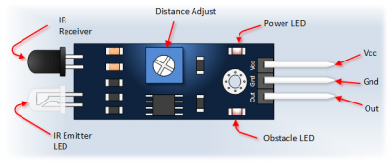

Figure : Line color detection using IR sensor

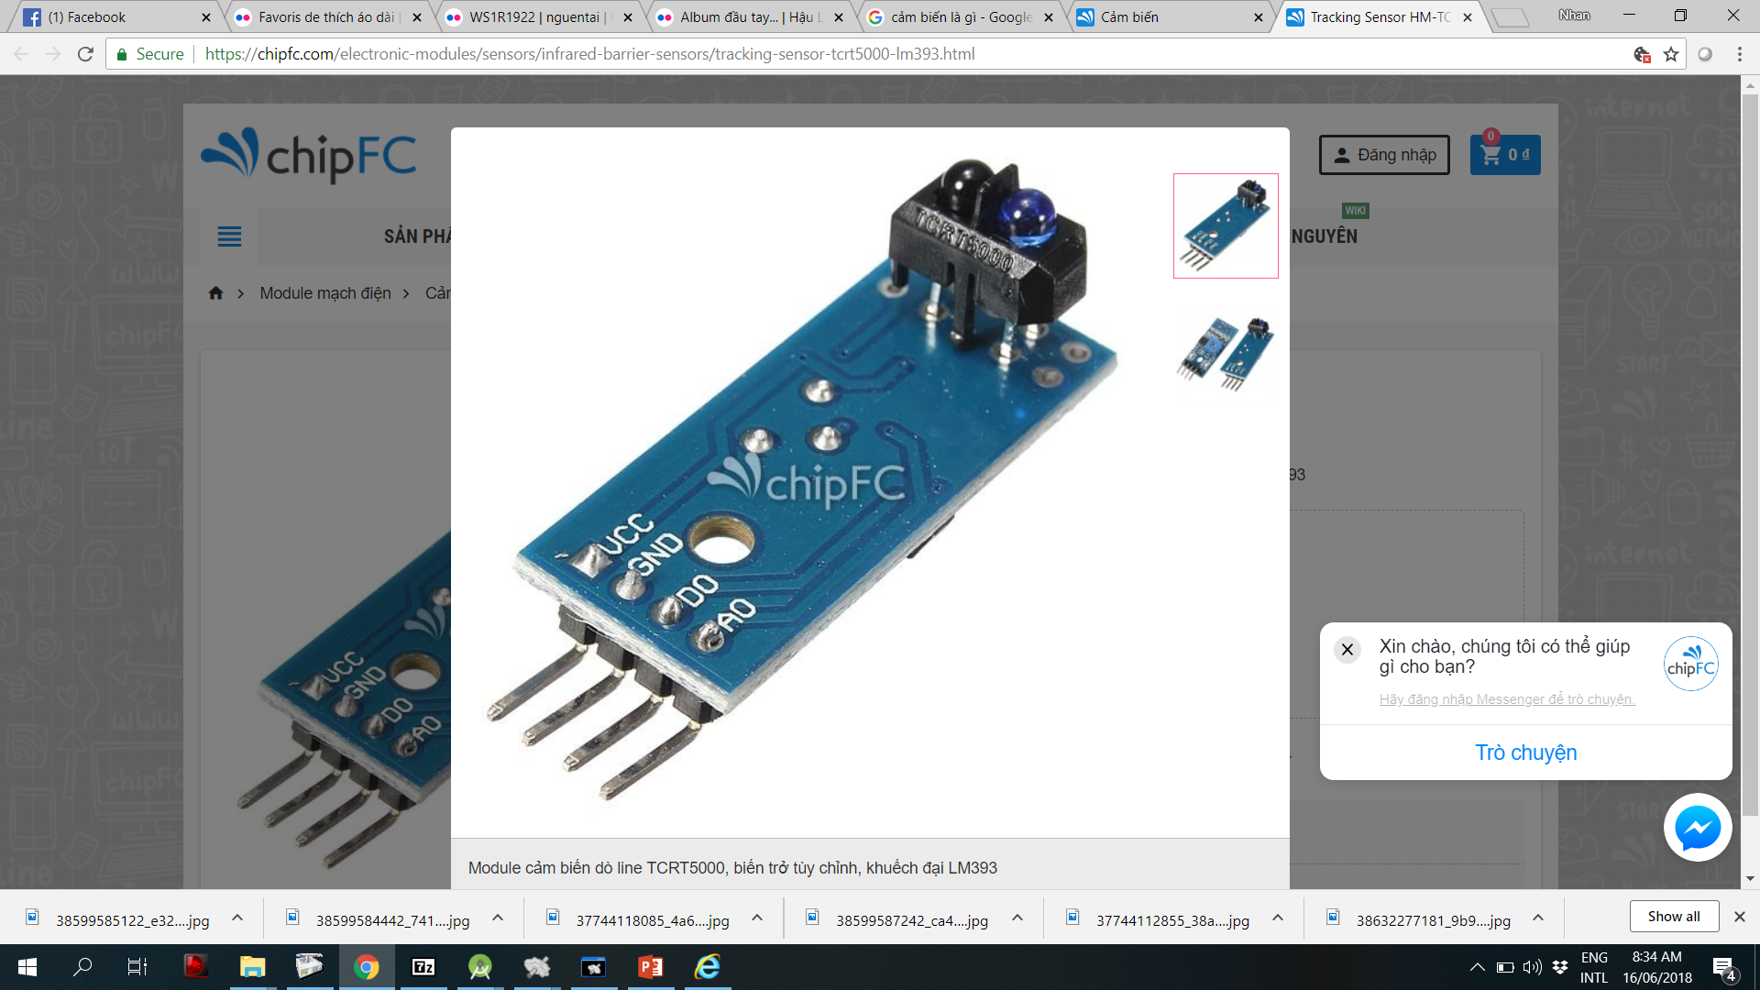

Figure : Real PCB sensor board

Basically, there are two infrared LED (Led Emitting Diode) on the board: a transmitter (IR LED) and a receiver (photo diode). Based on the reflection light, the output voltage is change. Specifically, when there is a strong reflection, the output voltage is high. Otherwise, the output voltage is low. This principle is illustrated in Figure 3.

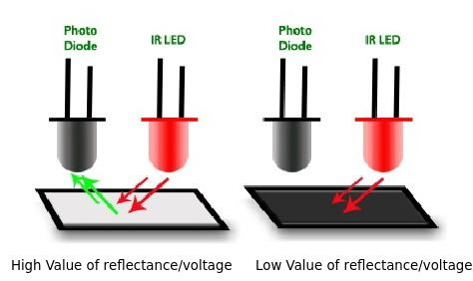

Figure : Output voltage is changed according to the reflection light

# Read Sensor Value

Figure 4: Header pins on the Arduino Robot

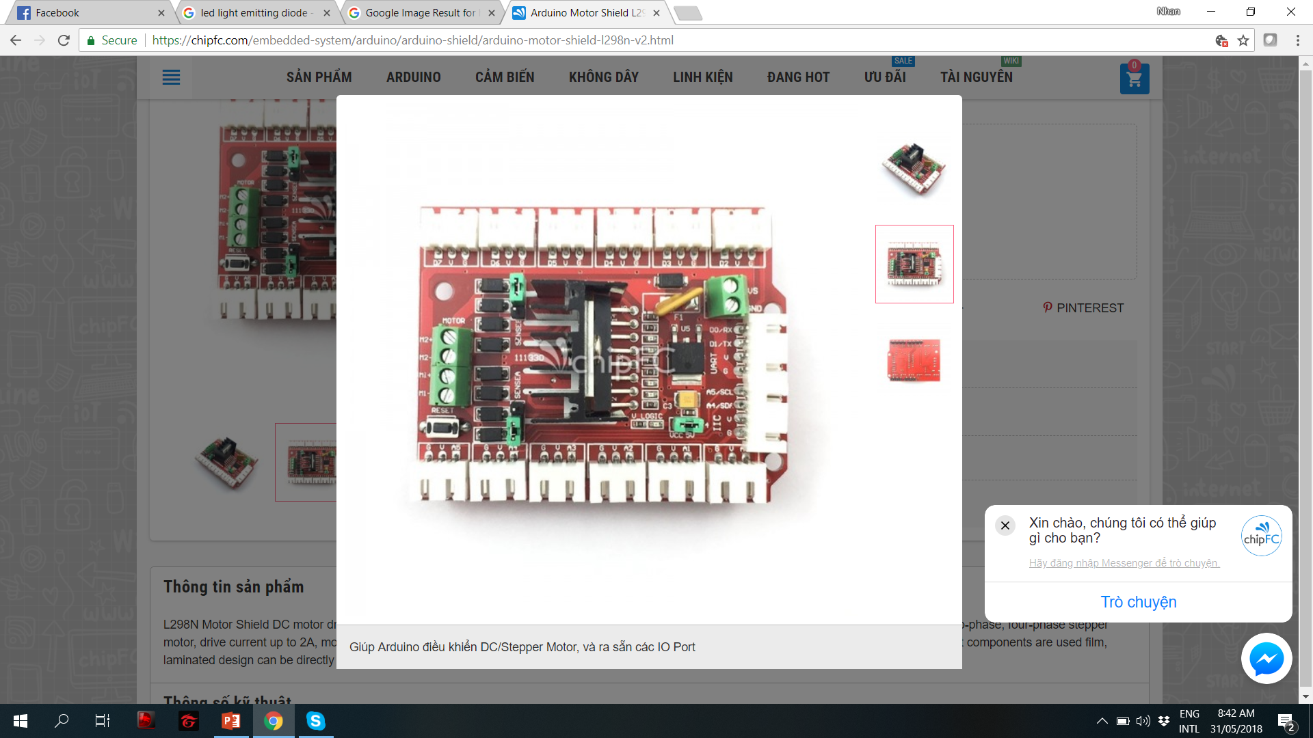

A5

A4

A3

A2

A1

A0

D7

D6

D5

D4

D3

D2

In order to read the output voltage from sensor circuit, it is mandatory to connect to an analog pin of the Arduino. Currently, the Arduino board supports 5 different analog ports. In this manual, the left sensor is connected to port A5 while the right sensor is connected to port A0. Please checking carefully the connection before powering the Robot. Three pins in the sensor circuit are GND (ground voltage, or 0V), VCC (voltage supply, or 5V) and OUT, which need to connect to G, V and A5 (or A0) accordingly.

Figure 5: Three pins in the Robot port: G (Ground), V (Voltage supply) and A5 (analog pin in Arduino)

G

V

A2

# Set Compared Value

**#define WHITE_ZONE 0**

**#define BLACK_ZONE 1**

**#define COMPARED_LEFT 500**

**int left_sensor_value;**

**int left_sensor_zone;**

**void setup()**

**{**

**pinMode(A5,INPUT);**

**Serial.begin(9600);**

**}**

**void loop()**

**{**

**left_sensor_value = analogRead(A5);**

**if(left_sensor_value < COMPARED_LEFT)**

**left_sensor_zone = BLACK_ZONE;**

**else**

**left_sensor_zone = WHITE_ZONE;**

**Serial.println(left_sensor_zone);**

**delay(1000);**

**}**